

Submitted By:
Muhammad Ahmed Subhani
SU92 – BSSEM – S25 – 018
Section: 4-A

Submitted To:
Sir Rasikh Ali

Department of Software Engineering
Superior University, Lahore
LAB 1
Question 2
Program:
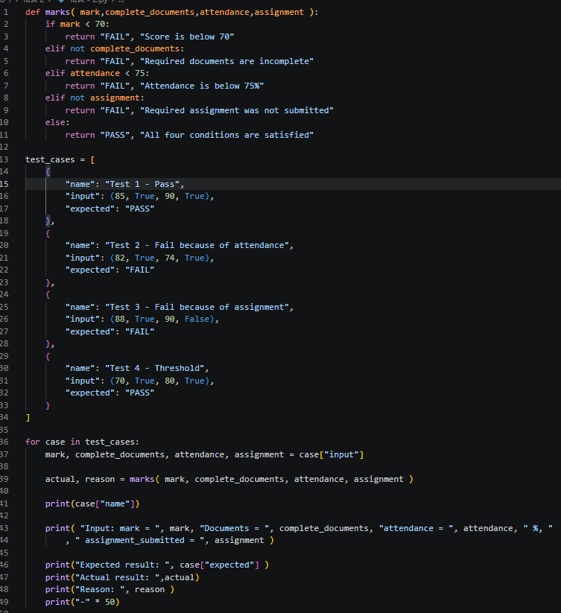
Explanation:

def marks( mark,complete_documents,attendance,assignment ):
if mark < 70:
return "FAIL", "Score is below 70"
elif not complete_documents:
return "FAIL", "Required documents are incomplete"
elif attendance < 75:
return "FAIL", "Attendance is below 75%"
elif not assignment:
return "FAIL", "Required assignment was not submitted"
else:
return "PASS", "All four conditions are satisfied"

We created a function by name marks and gave him 4 input parameters. The mark is used to check that either the marks of that person is above 70 or not, if below 70 return Fail. Then we use elif to check other conditions like not complete_documents and like the word it checks that either the person has the complete_documents or not. If a person does not have the complete_documents the condtion becomes true. The next elif statement checks if the attendance is less then 75, if the attendence is less then it returns Fail is yes then condition is breaked and move on to next elif statement which check not assignment and like the word it checks that either the person submited his assignment or not. At the end in else statement it returns Pass if all statement are True.

actual, reason = marks( mark, complete_documents, attendance, assignment )

Here actual is used to store PASS or FAIL while reason stores Required assignment was not submitted.

test_cases = [
{
"name": "Test 1 - Pass",
"input": (85, True, 90, True),
"expected": "PASS"
},

Default values or test cases that are used to test. They are also written in the same order as stated in the parameters of the marks function, def marks( mark, complete_documents, attendance, assignment ):. The name in test case is just a name has to do nothing with parameters or case test solving. The input is what matters, 85 are the marks, True is bassically either a person has complete documents or not in this case yes so True, 90 is attendence which states the attendence of the person and also True is matched with assignement checking that either a person has completed their assignement or not. Expected is passed as PASS because the current condition is true which is being matched or checked with th if – elif condition that we wrote in marks function.

for case in test_cases:

The for loop is used used to check each test case againt the if – elif marks function conditon.

mark, complete_documents, attendance, assignment = case["input"]
actual, reason = marks( mark, complete_documents, attendance, assignment )

As stated above about this each input in matched with mark, complete_documents, attendance, assignment above also how they are matched is explained. Also actual, reason = marks( mark, complete_documents, attendance, assignment ) is also expalined in well manner too.

print(case["name"])

Used to print the name of each test case. Where if case is 1 then 1st case if case is 2 then 2nd case.

print( "Input: mark = ", mark, "Documents = ", complete_documents, "attendance = ", attendance, " %, ", " assignment_submitted = ", assignment )

These statements are also used to print the marks, complete_documents, attendance, assignment.

print("-" * 50)

Makes the code look cleaner by just printing – 50 time at the end of each case.

Output:
